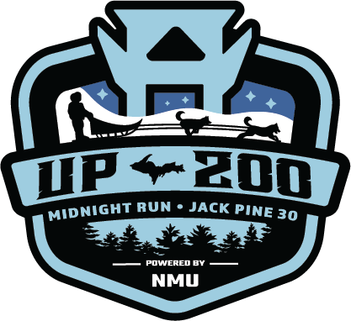
Sled Banner Sponsor
A sled banner is created to showcase your support by putting your company name on a durable banner which is attached to a sled and carried by a musher throughout one of our races. After the race, the banner is removed from the sled and returned to you. The UP200 and all of it’s mushers truly appreciate your support of this premier sled dog event!
Business Name: ____________________________________________________________
Address: ____________________________________________________________
Phone: ________________________ Contact Person: _____________________
Date of Sale: ________________________ Race Year: __________________________
Amount Paid: ________________________ UP200 Contact: ______________________
Method of Payment: Check #_____________ Online: Credit Card_______ PayPal:_______
Name to Appear on Banner: __________________________________________________
Cut at dotted line: Retain top portion and return lower portion to UP200, PO Box 15, Marquette, MI 49855
Please make checks payable to UP200 or payments can be made online at UP200.org.
-------------------------------------------------------------------------------------------------------------------------------------------------------------------------
Sled Banner Sponsor
Business Name: ____________________________________________________________
Address: ____________________________________________________________
Phone: ________________________ Contact Person: _____________________
Date of Sale: ________________________ Race Year: __________________________
Amount Paid: ________________________ UP200 Contact: ______________________
Method of Payment: Check #_____________ Online: Credit Card_______ PayPal:_______
Name to Appear on Banner: __________________________________________________

